Week 3 Day 2:
Home Assignment :
Integrate the Jira to the exiting userstory to testcase generator codebase

This is the overall requirement and Hint for Jira integration Assignment.
Requirements:
- Add a “Connect Jira” button in UI page to establish a connection (Base URL, email, API token).
- After successful connection, show a dropdown listing all user stories.
- Add a “Link Story” button that fetches story details (Title, Description, Acceptance Criteria).

- Add backend connectivity to Jira.
- Once connected, populate the stories; on Link Story, display the details.
Step 1: npm run dev
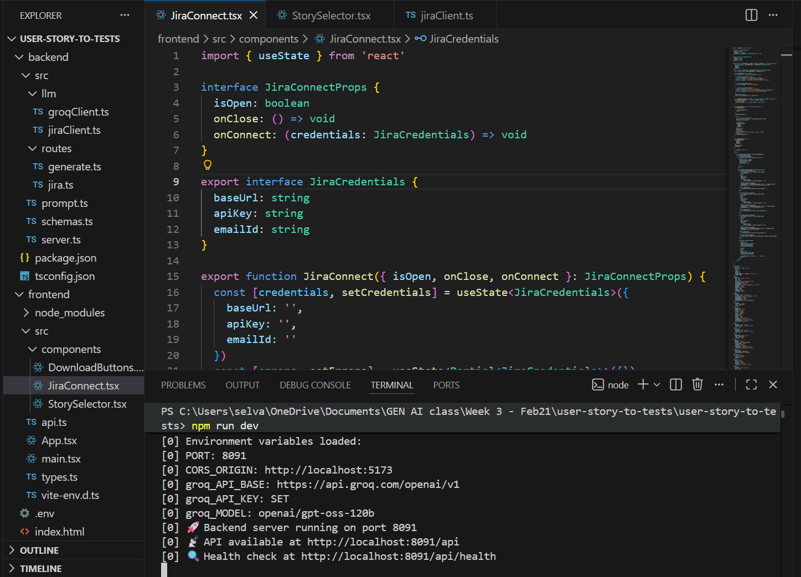
Step 2:
Jira connect successfully .
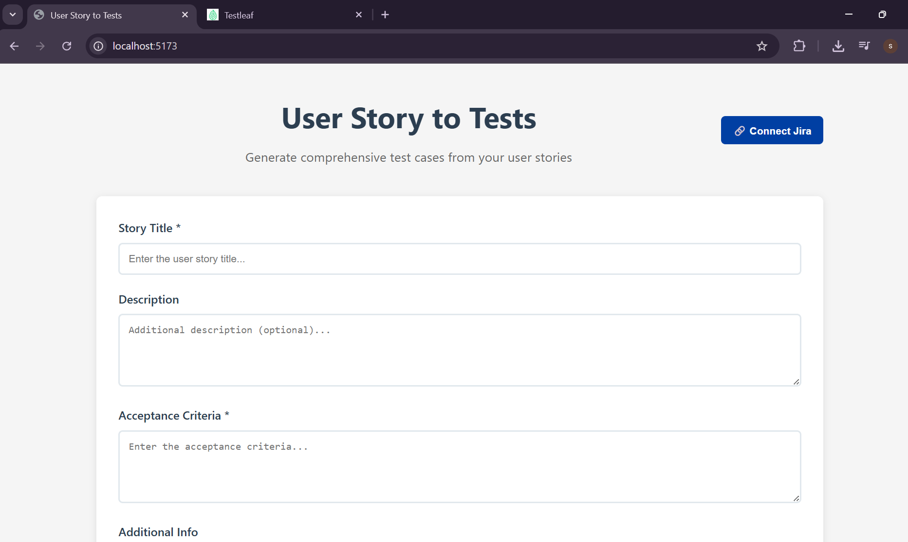
Entered the details:
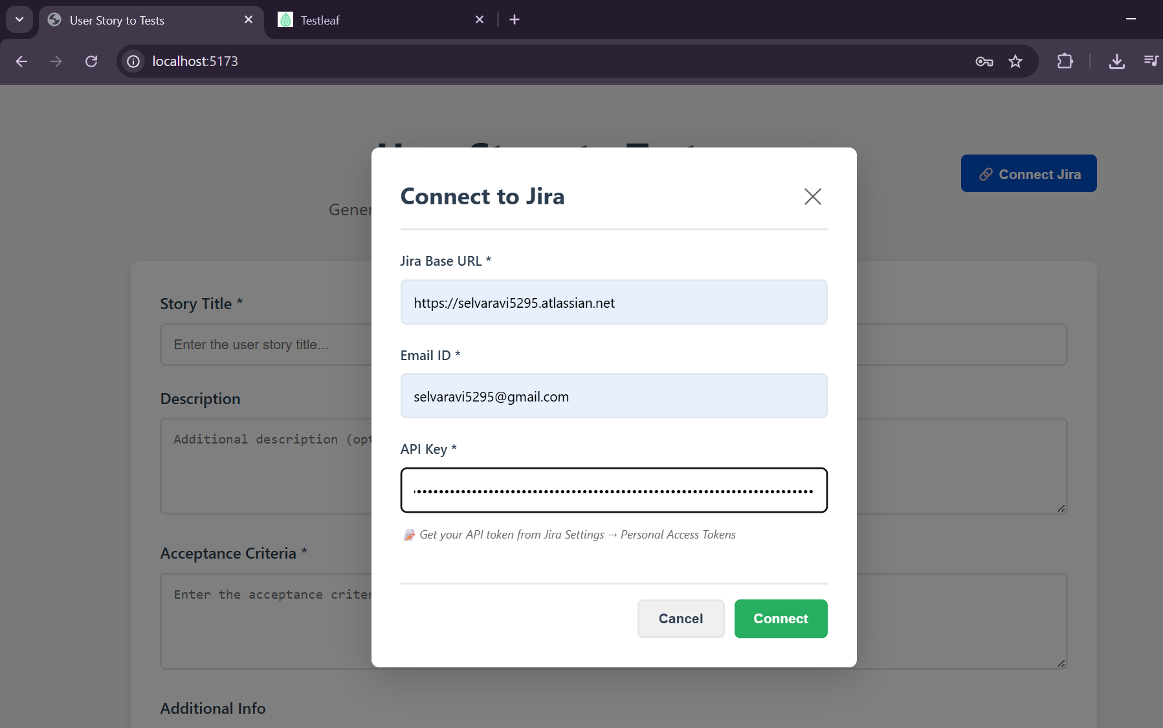
Connected to Jira successfullyL
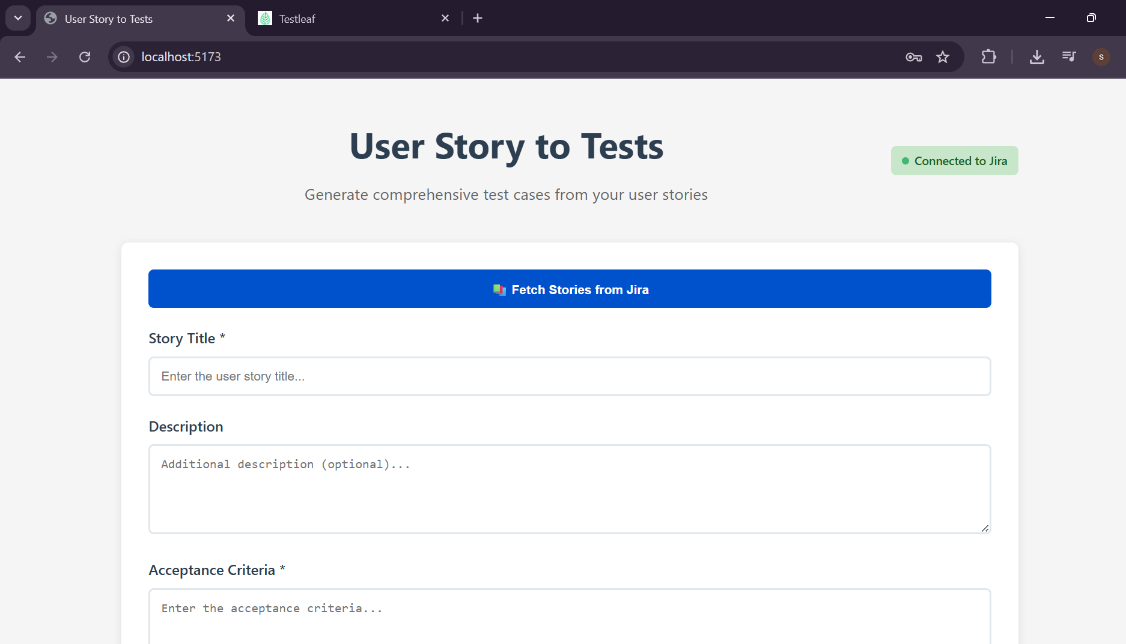
Click on the fetch stories from jira:
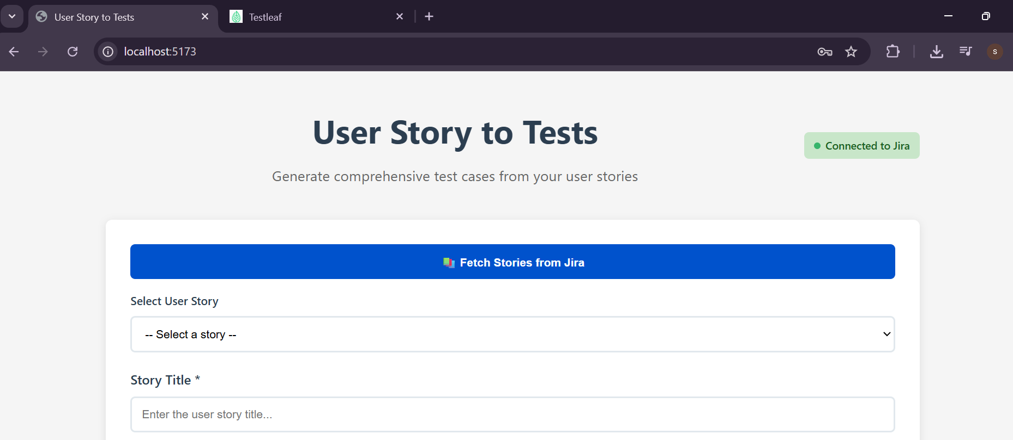
User stories are listed successfully:
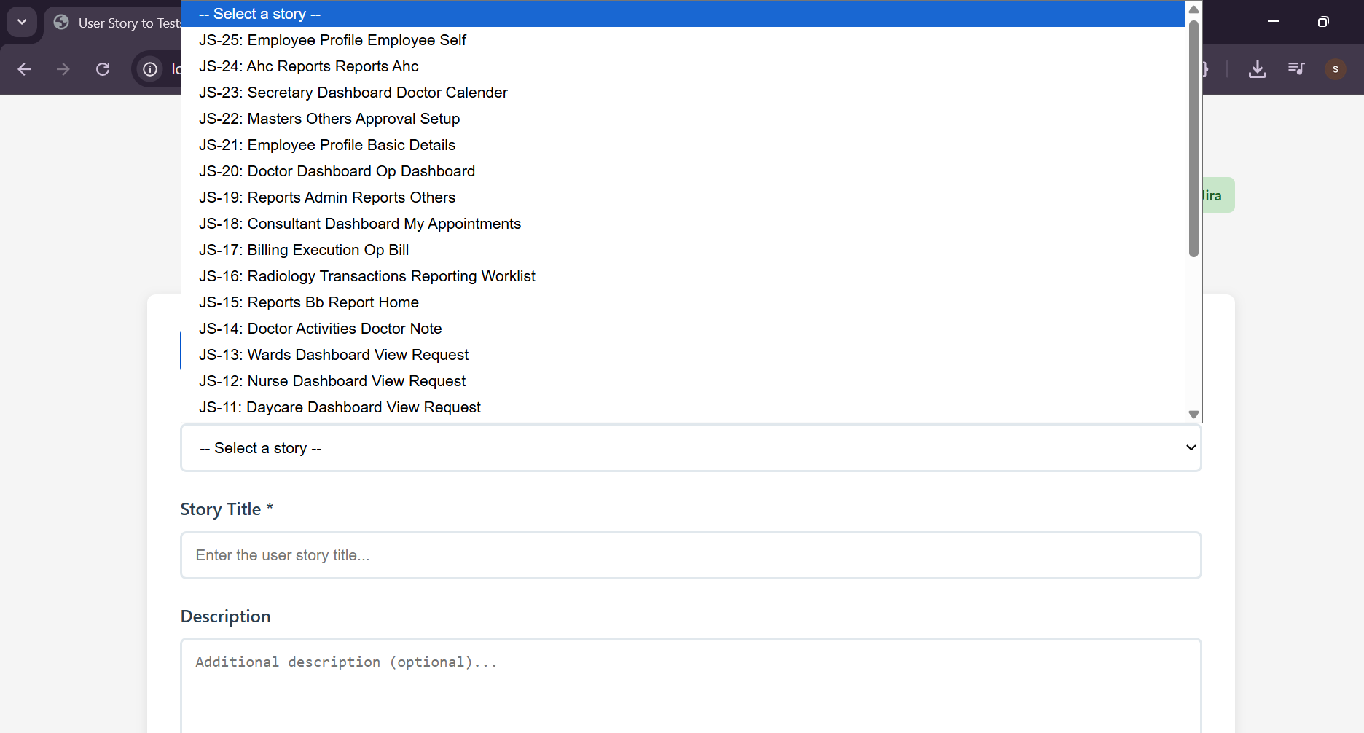
Selected any user story:
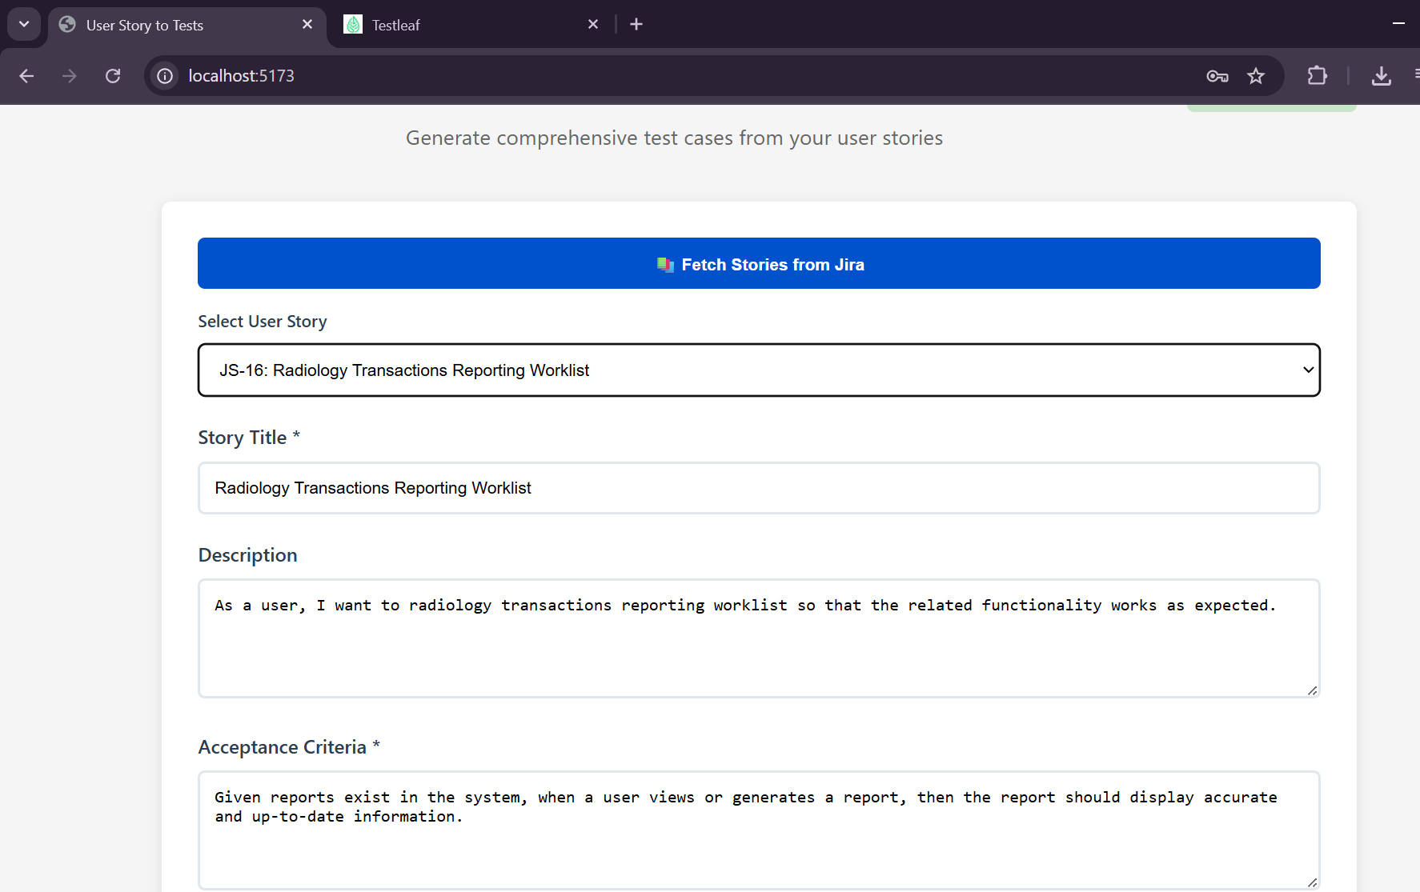
Click on generate:
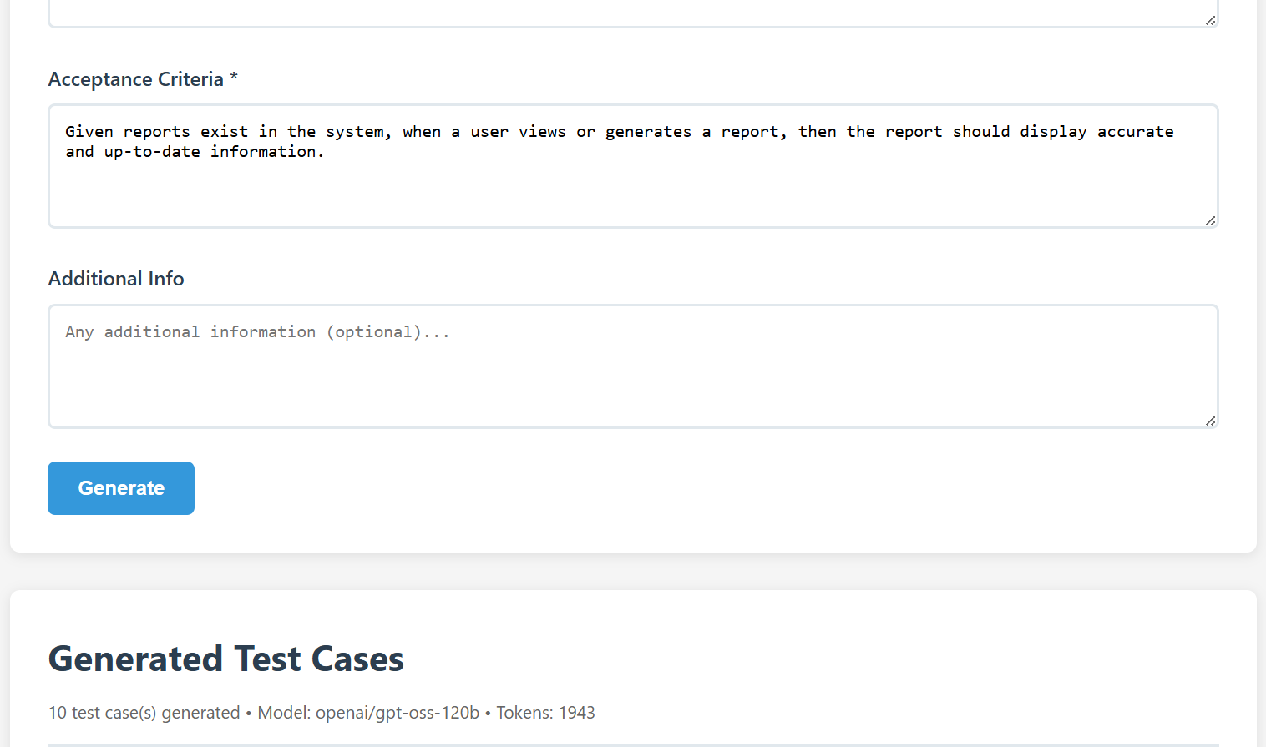
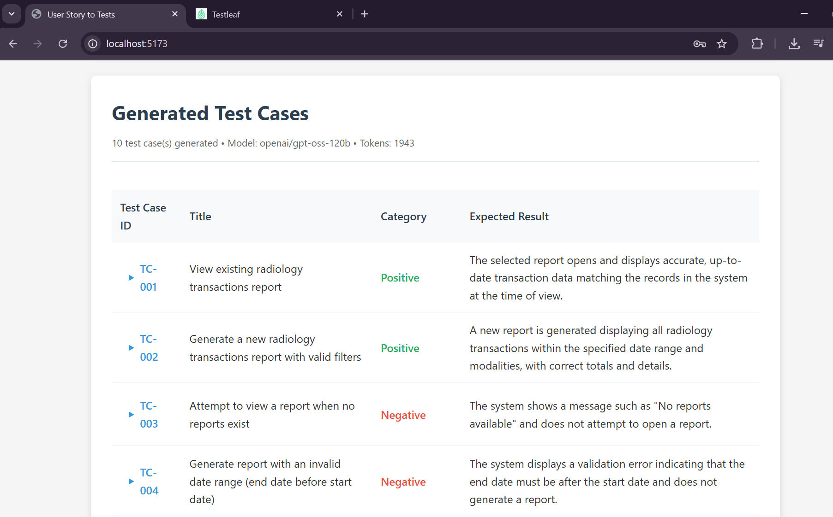

Test cases generated successfully for the selected user story.

